Book Projects
Student Name: Book Project:

Each book project is worth 40 points.
Elements: | Points:
Include book title, author, and your name | /5pts
C.U.P.S. (1 point will be taken for each error) | /5pts
Neat and organized | /5pts

3D Setting | Points
Create a 3D setting using facts from the book. | /10pts
Characters are represented based on the book (3D or flat) | /5pts
A paragraph describing the setting and using facts from the book to support your setting | /10pts

T.V. Box | Points
Create a tv set using a box and have a stream of events from the book
Events summarize entire book or an interesting event in the book | /10pts
At least 6 frames are used in color | /10pts
TV is functional | /5pts

Board Game | Points
Include vocabulary, information, and characters from the story | /10pts
Include a set of instructions that tell the rules and object of the game | /10pts
Make game board, game pieces, and cards | /5pts

Movie Poster | Points
Create a promotional poster that includes title and author | /5pts
Include a list of book major characters and movies stars staring as them | /10pts
Paragraph summarizing the story | /10pts

Book Product | Points
Create a product to sell in a box set or to the characters in the story | /5pts
Create a prototype of the product | /10pts
Include an advertisement with the name, price, and why someone should buy it | /10pts

Examples:
3D Setting
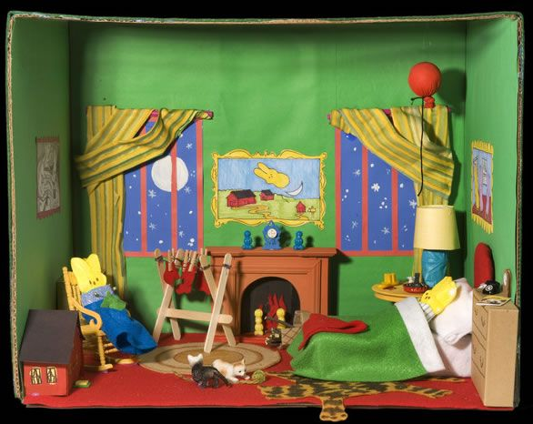
TV box
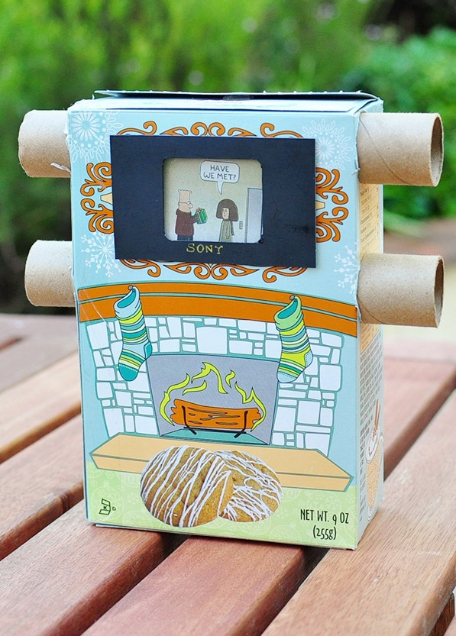

Game board
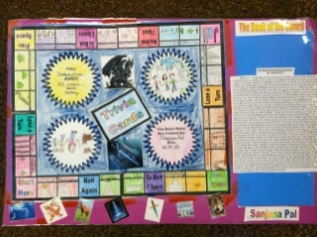
Movie Poster
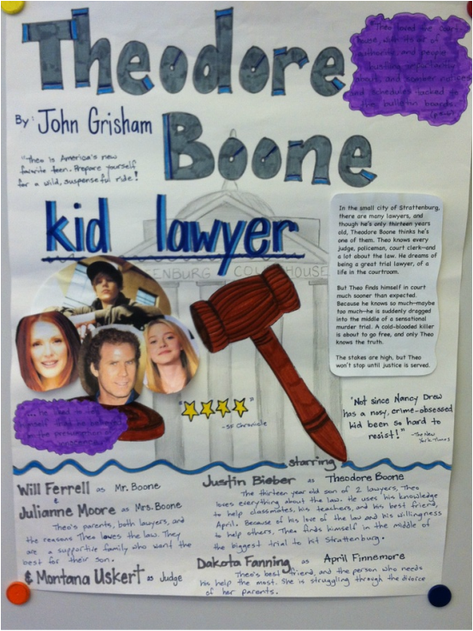
Book product
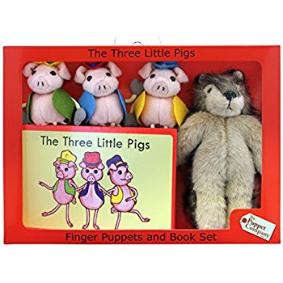
Book product ideas:
Holes: Automatic Shovel
James and the Giant Peach: Peach Tea

